**Leader Overview**

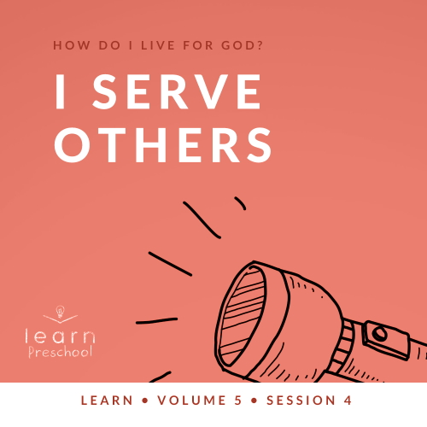

**Volume Overview**

**How do I live for God?**

*As we learn how to live for God, we’ll explore what that looks like in our everyday life. We know the Bible speaks to us, and God wants each of us to live connected to other believers. So, if that’s all true, how do we put God first? How do we get through all the confusion and uncertainty in this world? What does God expect when it comes to giving? How can we show others we care? In these sessions, we’ll consider what the Bible has to say in response to very important questions like these*.

**Session Overview**

**I Serve Others**

*In this* **Learn** *session, preschoolers discover that we can’t live for God if we aren’t willing to serve others. It’s easy in our pursuit of God to ignore those around us, but loving people pleases God. The Good Samaritan loved his neighbor and lived for God by simply serving the injured man*.

**Bible Lesson**

The Good Samaritan

[Luke 10:30–37](https://ref.ly/logosref/Bible.Lk10.30-37)

**Faith Fact**

I serve others.

**Faith Verse**

[Matthew 6:33](https://ref.ly/logosref/Bible.Mt6.33) NLT

“Seek the Kingdom of God above all else, and live righteously, and he will give you everything you need.”

**Preparing for the Session**

**Leader Preparation Time: 20–25 Minutes**

|  |
| --- |
| ***You Will Need***  ***Preservice Activities***  *• Small adhesive bandages, one per kid*  *•* ***Bible Story Warm-Up Page****, one per group*  *• Leader’s Choice snack*  *• Toys*  ***Large Group***  *• Bible*  *• Worship songs (Song suggestions: “What a Mighty God We Serve” by Listener Kids; “Brave” by Saddleback Kids; “No Fear in Love” by Elevation Church Kids)*  *• For groups not using a phone or tablet only, add:*  *• Projector or TV*  *• Laptop*  *•* ***Faith Fact Sound*** *video (bell ringing)*  *•* ***Faith Fact Slide***  *•* ***Faith Verse Slide***  *•* ***Bible Lesson Video A***  *•* ***Bible Lesson Video B***  ***Small Group***  *• Construction paper, one sheet per kid*  *• Tape*  *•* ***Small Group Activity Page****, one per kid*  *• Crayons and markers*  *• Rolls of toilet paper or crepe paper*  *• Dominoes*  *To access session content and videos from a computer, visit:* [*BibleEngagementProject.com/downloads*](https://bibleengagementproject.com/downloads) |
| ***Getting Ready***  ***Preservice Activities***  *• Set out toys and snacks.*  *• Print the* ***Bible Story Warm-Up Page****, one per group.*  ***Large Group***  *• Download videos and slides if needed.*  *• Select worship song(s) and have them ready to play.*  ***Small Group***  *• Roll each sheet of construction paper into a tube and secure it with tape.*  *• Print copies of the* ***Small Group Activity Page****, one per kid.* |

*First time leading* Learn *for Preschool? Check out the* [Facilitator Guide](https://0b769b0ed3569ef9d18b-f88d8272f61086866d50d048b43ef630.ssl.cf2.rackcdn.com/sites/biblengagementproject/Listen_Facilitator_Guide.pdf).

**Preservice Activities**

*See what’s needed at the beginning of the session.*

**Bible Story Warm-Up**

*As kids are coming in, have them sit in a circle*.

Today, we’ll learn how to serve others. Serving them is one way that we can show God’s love to them. Raise your hand if you love God. *(Group response)* I’m glad. I want everyone to know that God loves them, so they can love God, too. One way we can show others God’s love is by taking care of them. How many of you have ever been hurt? *(Group response)* Who helped you when you got hurt? *(Allow responses.)* Wow! That was so nice of them to help you.

• *Give each kid a small adhesive bandage*.

Sometimes when we get hurt, we need help to get better. Someone who cares for you may need to use a bandage to help you feel better. Let’s help this injured man. When it’s your turn, place your bandage on him. When you do, I want you so say, “**I serve others.”**

• *Show kids the* ***Bible Story Warm-Up Page***.

• *Have each kid apply their bandage to the page*.

What does it mean to serve?

Has anyone ever served you?

What did they do to serve you?

Those are great answers! They remind me of a time that someone served me.

• *Tell a personal story of a time that someone served you*.

Today, we’ll hear a story Jesus told about a man who was hurt. God loves it when we serve other people because it shows them how much He loves them. I’m so excited to learn with you today.

**Snack**

**Leader’s Choice**

Today, our lesson is about serving, so I think this is a great time for you to practice serving.

• *Choose kids to help serve the snack*.

My helpers will pass out a snack to you. By serving you, they’ll put your needs first. Isn’t it awesome when we serve others? *(Group response)*

One of the reasons that we serve other people is because we care about them. Serving others isn’t always easy. It takes our time and energy. When we help others, we might need to give something we have like our money or share something we own.

Who is someone you can serve this week?

What is one way you can serve them?

**Free Play**

*Any extra time can be spent playing with toys*.

**Transition**

*A few minutes before service begins have kids make their way to the large group area and sit in their designated areas*.

**Large Group**

**25 Minutes**

*See what’s needed at the beginning of the session.*

**Introduction**

Wow! I’m so excited to be here with you. If you’re excited to be here, wave your hands in the air. *(Group response)* Today, we’ll learn that God wants us to serve others. *(Hold up the Bible.)* I love the Bible because it shows us how to live for God. As we look at the Bible today, we’ll hear an amazing story about someone who cared about other people. When we care about other people, we serve them. Serving is another way of saying that we help them.

**Faith Fact**

Our Faith Fact today is all about that. **I serve others**.

• *Show the* ***Faith Fact Slide***.

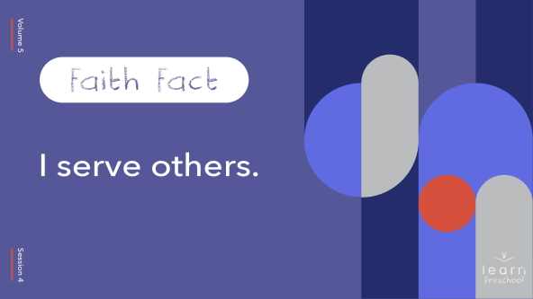

Let’s say it together. Place your hands on your hips and stand like you’re a superhero. You’re here to save the day by helping people.

• *Demonstrate how to stand like a superhero*.

Now, let’s say the Faith Fact. **I serve others.** Awesome! Place one hand in the air like we’re about to fly away. Let’s say the Faith Fact again. **I serve others**.

**Bible Time**

You all did an amazing job saying our Faith Fact today. Our Faith Fact reminds us that we can care for other people like God cares for us. One of the best ways to learn about God and the way He wants us to live is to read the Bible. I love it when we get to do that together. I have an idea. Why don’t we see what Lizzy is up to and find out what she’s been learning in the Bible?

• *Play* ***Bible Lesson Video A***.

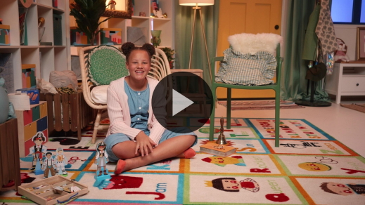

You kids are so good at helping Lizzy solve those clues. Who enjoyed today’s Bible story? *(Group response)* Who helped the injured man in the story? *(Allow responses.)* That’s right! The Good Samaritan helped the man who was hurt. Other people walked by, but they didn’t stop to help him. God wants us to notice people who need help. He’s pleased when we serve others like the Samaritan did.

**Worship**

Serving others is one way that we worship God. We also can show God how much we love Him when we worship Him. When we focus on God, we show Him that He’s important to us. Let’s seek Him first as we worship today.

**Praise**

Are you glad God loves us? Clap three times. *(Group response)*

Are you glad we can serve others? Spin around slowly. *(Group response)*

Who’s ready to worship Him? Wave your hands back and forth. *(Group response)*

**Sing**

Now, let’s worship God as we sing.

• *Lead the kids in singing one or two songs. See song suggestions at the beginning of the session*.

**Prayer**

I love it when we worship and sing praises to God. Now, everyone bow your head and let’s pray.

|  |
| --- |
| Dear God, thank You for caring about me. Help me to care about those around me as I serve others. Amen. |

**Bible Time cont’d**

Now, it’s time to practice our Faith Verse. Let’s check back in with Lizzy.

• *Play* ***Bible Lesson Video B***.

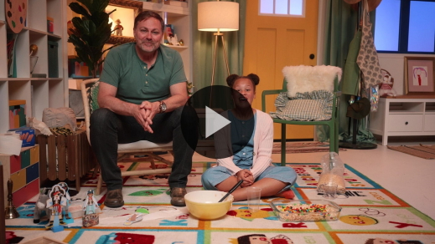

Wow! You’re doing a great job of learning our Faith Verse! This verse reminds us to put God first and to live like He wants us to. When we put God first, it makes it easier to serve others.

In our Bible story today, we heard about someone who did a really good job of serving others. How many people passed the hurt man before someone helped him? *(Allow responses.)* That’s right! Two people passed him, and they didn’t stop to help him. The Good Samaritan not only took care of the man when he was hurt, but also took the injured man to a place where other people would keep taking care of him. The Good Samaritan paid for the injured man to get care so he could get better. Sometimes when we care for others, it will cost us. When we serve others, it pleases God because He knows we are living for Him.

**Response Time**

• *Play a worship song quietly*.

Let’s stop and think about what we’ve learned from the Bible today. This is our chance to respond to God. I want you to give yourself a big hug and think about what it feels like when someone takes care of you. Now, let’s pray together and ask God to help us serve others. We can care for others to show how much God cares for us.

• *Optional: Have kids repeat prayer after you*.

|  |
| --- |
| Dear God, it’s not always easy to serve others, so help me to put them first. I want to show them how much You love them by how I treat them. Amen. |

**Faith Verse**

Did you know it also pleases God when we learn His Word? Let’s practice our Faith Verse together.

• *Show the* ***Faith Verse Slide***.

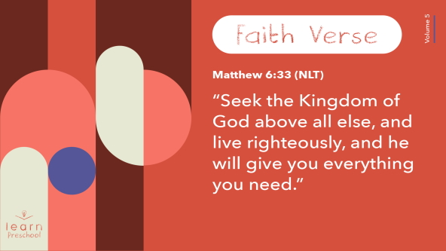

[Matthew 6:33](https://ref.ly/logosref/Bible.Mt6.33) (NLT)

“Seek the Kingdom of God above all else, and live righteously, and he will give you everything you need.”

**Matthew** *(hands at waist, spread apart, palms up and out)*

**6**: *(hands together like a clap)*

**33** *(hands opened to “book”)*

**“Seek the Kingdom of God** *(one hand at brow, “search” left and right)*

**above all else**, *(point up with both index fingers)*

**and live righteously**, *(clasp hands in prayer waist-high)*

**and he will give you** *(open hands flat at waist)*

**everything you need.”** *(move hands out to side and then clap)*

Great job! You kids are doing so great at learning our Faith Verse.

**Closing**

Who learned about God today? *(Group response)* We’ve done so many great things today. We heard a Bible story, practiced our Faith Verse, and we even learned a new Faith Fact. When we serve others, we get to tell them how much God loves them without ever using our words. We tell them simply by how we treat them.

• *Play the* ***Faith Fact Sound*** *video (bell ringing)*.

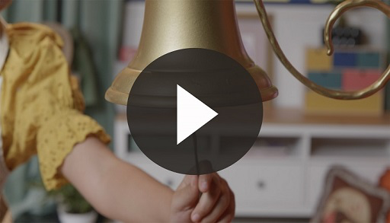

• *Show the* ***Faith Fact Slide***.



I love that sound because it means we get to practice our Faith Fact one more time: **I serve others.** Let’s shout it together. **I serve others.** Now, we’re going to say it as fast as we can. **I serve others**.

**Dismissal to Small Groups**

I’ve had so much fun with you. It’s time to go to our small groups next so that we can keep learning about God.

• *Dismiss the kids by groups*.

|  |
| --- |
| ***Leader Tip:*** *This can be done by assigning color teams or by age groups. Note that some young preschoolers may not know their age. Using a colored sticker, jersey, or wristband will help separate the kids and help identify their small groups.* |

**Small Group**

**25 Minutes**

*See supplies and prep instructions at beginning of session or in each activity below.*

|  |
| --- |
| ***Leader Tip:*** *Small groups can alternate to each circle, or all groups can do each activity at the same time. If you choose to alternate, you will need at least one leader per circle.* |

**Circle 1**

**Group Connection**

**Seek First**

|  |
| --- |
| ***You Will Need***  *• Construction paper, one sheet per kid*  *• Tape*  ***Getting Ready***  *• Roll each sheet of construction paper into a tube and secure it with tape.* |

We have an amazing Faith Verse. Can you do the actions with me?

• *Lead kids through Faith Verse actions*.

**Matthew** *(hands at waist, spread apart, palms up and out)*

**6**: *(hands together like a clap)*

**33** *(hands opened to “book”)*

**“Seek the Kingdom of God** *(one hand at brow, “search” left and right)*

**above all else**, *(point up with both index fingers)*

**and live righteously**, *(clasp hands in prayer waist-high)*

**and he will give you** *(open hands flat at waist)*

**everything you need.”** *(move hands out to side and then clap)*

Great job! The very first thing this verse tells us is that we need to seek God first.

• *Give each kid a construction paper tube*.

When we seek something, we look carefully for it. Take your tube and look around the room. When I call on you, I want you to tell me the very first thing you see. *(Allow responses.)*

Wow! You did a great job seeking out different things in the room. Just like when I called your name and you focused your attention on something, God wants you to focus on Him. When we seek God first, He’ll teach us how to live the way He wants us to. He takes care of what we need.

**Circle 2**

**Activity Page Time**

**Make Your Way to Help**

|  |
| --- |
| ***You Will Need***  *•* ***Small Group Activity Page****, one per kid*  *• Crayons and markers*  ***Getting Ready***  *• Print copies of the* ***Small Group Activity Page****, one per kid.* |

You’ve done such a great job listening today. Now, we have a fun activity to do.

• *Give each kid a* ***Small Group Activity Page*** *and a marker*.

What do you see on the paper? *(Allow responses.)* I think this is a picture of the injured man from our Bible story. All around him are different things that may help him feel better. Circle the things that you would use to serve him with the marker. Every time you circle one, I want you to say our Faith Fact: **I serve others**. Now, let’s color our pictures.

• *Give kids time to complete the page and color it with crayons*.

How do you think it makes God feel when we serve others?

What’s your favorite way to help others?

**Circle 3**

**Feet-to-Floor Game Time**

**Bandage Race**

|  |
| --- |
| ***You Will Need***  *• Rolls of toilet paper or crepe paper*  *No prep needed for this activity.* |

Who’s ready to have some fun and play a game? *(Group response)* Who can tell me what our Bible story was about today? *(Allow responses.)* That’s right! Our Bible story today was about the Good Samaritan who helped take care of someone who was hurt. Today, we have a fun game where you’ll help bandage your leader. Wait! What? You’re going to wrap me up?

I guess I’m going to be the injured man, and you’re going to be the Good Samaritan. When you’re finished wrapping me from head to toe, you’ll shout the Faith Fact. That’s how I’ll know you are done. Okay, I think this will work best if you make a circle around me. Then, pass the roll from person to person to wrap me up with it.

• *Give the roll of toilet paper to one of the kids*.

• *Let them work together to wrap you like a mummy with the toilet paper*.

• *Optional: Let teams race each other. The first team to shout the Faith Fact wins*.

Wow! That was awesome! I know if I ever really get hurt, you can help. I’m amazed at how fast you wrapped the bandages around me.

• *During the activity, interrupt and practice the Faith Fact:* **I serve others**.

• *Play the* ***Faith Fact Sound*** *video. Review the Faith Fact even if you can’t play the sound*.



**Circle 4**

**Hands-On Learning**

**The Serving Effect**

|  |
| --- |
| ***You Will Need***  *• Dominoes*  *No prep needed for this activity.* |

Have you ever played with these before? *(Hold up a domino.)* You can do a lot of things with them. You can play a game with your friends, or you can stand them up in a row like this.

• *Line dominoes up in row on a table or the floor*.

When we only think about ourself and only help ourself, it’s like this one domino.

• *Pick up one domino*.

We can move it around and look at it, but one domino isn’t very much fun to play with. When we move it closer to the others and simply knock it down, what happens? *(Allow responses.)* It hits all the others, and it’s fun to watch.

• *Knock down the row of dominoes*.

The same thing can happen when we serve other people. When we use our life to show others how much God loves them, it creates this serving effect. We serve someone, and it makes us feel good. We serve someone, and it pleases God. We serve someone, and it makes them feel better. Imagine if that person then started serving someone else. When we seek God first and show others how much He loves them, it doesn’t affect just us. We can affect everyone around us.

Now, let’s practice serving. I’ll give you some dominoes to line up for someone else to knock down. When you’re done, say the Faith Fact: **I serve others.** Then, choose who gets to knock them down.

**Dismissal**

• *Play the* ***Faith Fact Sound*** *video (bell ringing)*.



• *Show the* ***Faith Fact Slide***.



Wow! We’ve had so much fun together, but it’s already time to go. Before we leave, let’s practice our Faith Fact one more time. Let’s say it as loudly as we can! **I serve others.** See you next time.

• *Send home the* ***Small Group Activity Page*** *with each kid*.

• *Remind parents that there are* ***Family Devotions*** *available on the app to do with their kid*.

• *Tell everyone the date and time for the next session*.

.